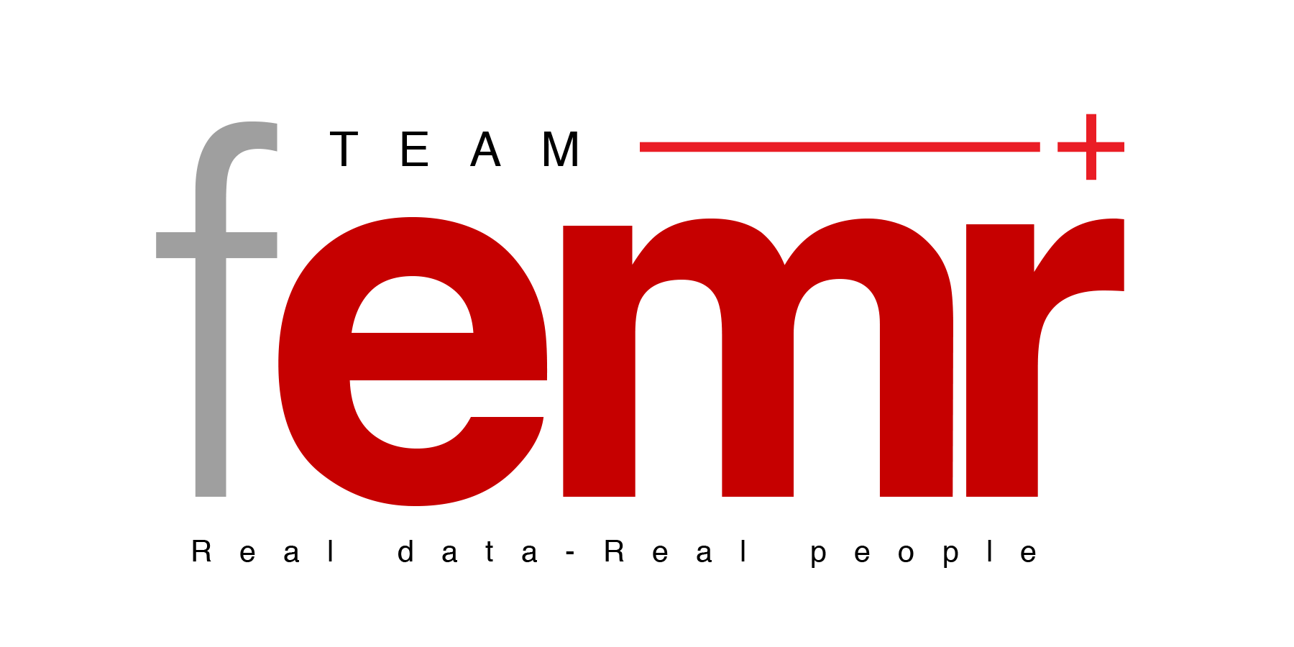

**Advisory Board**

**Announcement**

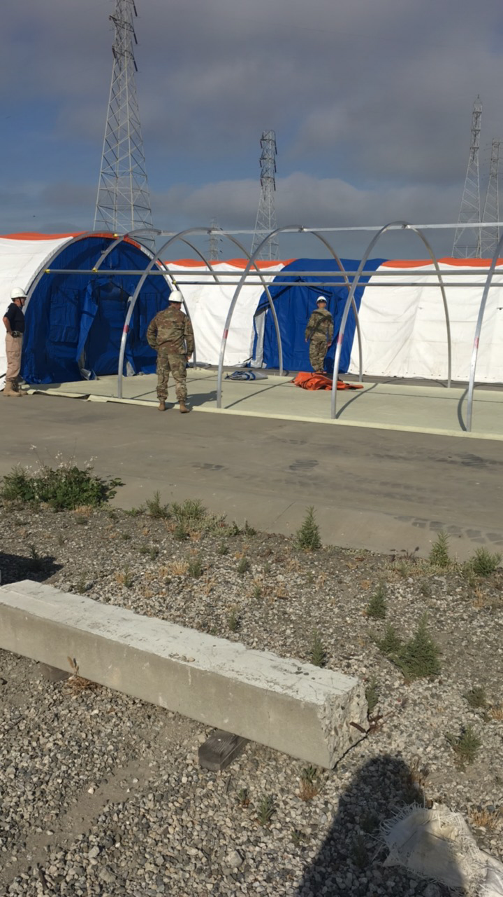**2017**

**From Team fEMR Bylaws:** “An Advisory Board will be comprised of anyone with the skill set and motivation to augment the Executive Board of Directors. Members of the Advisory Board will not be paid for their work, with the exception of reimbursements for any Personal expense spent on activities or items related to Team fEMR. The Advisory Board Will join the annual meeting of the Board of Directors in October of each year, and will be Available throughout the year for guidance on specific issues in their area of expertise. Members of the Advisory Board will be voted in by the simple majority Board Members and Members combined. Advisory Board members will not hold the power of casting an official vote on any issue. Advisory Board positions are for 3 years at a time. Any member of the Advisory Board may resign by filing a written resignation with the secretary. A member can have their membership terminated by a majority vote of the membership and Board Members combined.”

*It is with gratitude that we welcome the following members to serve on the Team fEMR Advisory Board:*

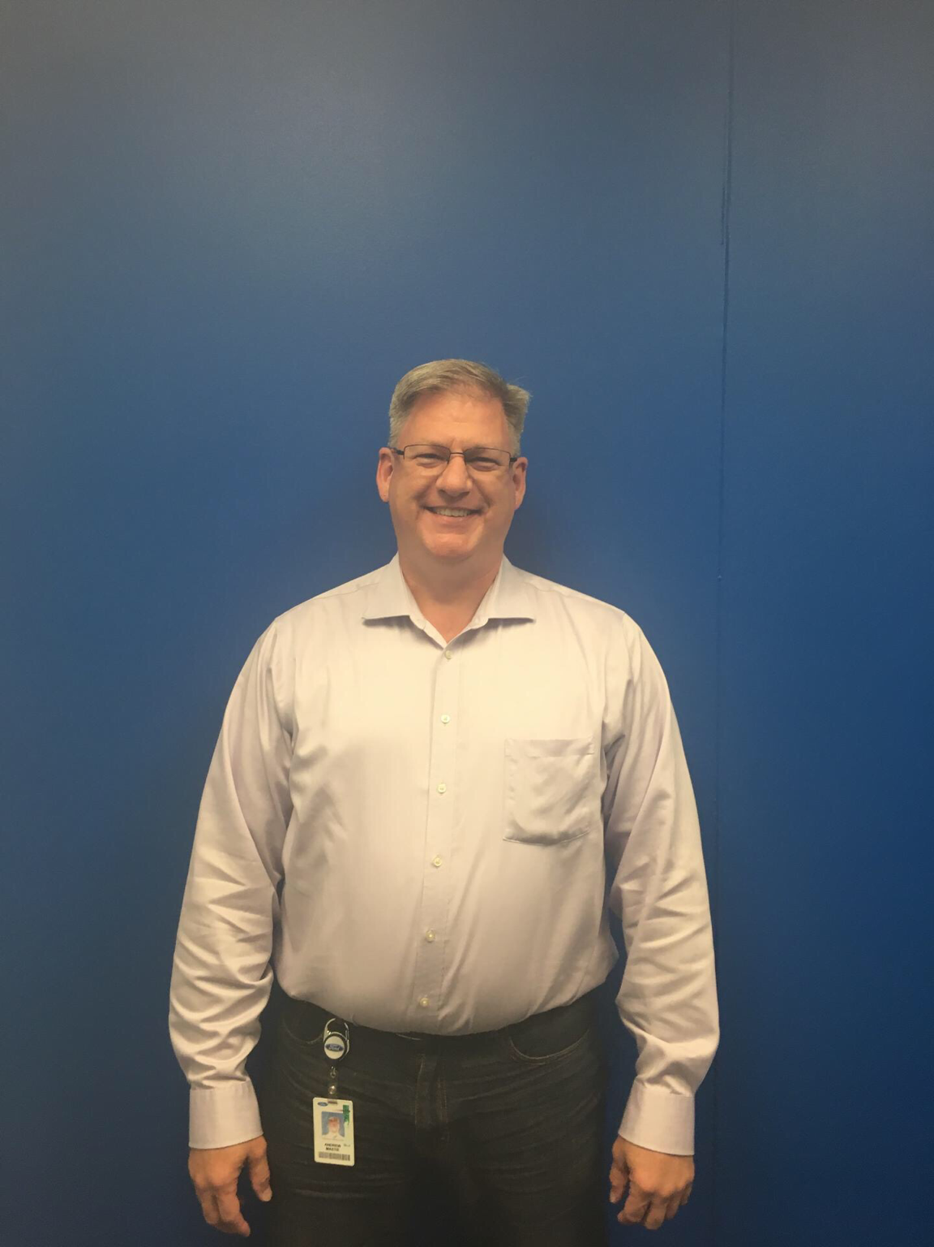

Andrew Mastie has extensive experience with both domestic and international IT projects, utilizing his Management, Engineering, Technical-Lead and Project Management skills to sell, design and implement software, network and/or infrastructure solutions that are in production around the world. His experience includes over 32 years of work in IT, with a large number of firms including both Fortune-500 and smaller companies, leaving him with a broad portfolio of cross-disciplinary IT skills, proven team and personnel skills, and a battle-tested reputation for project management excellence, and delivering uncompromising results. Often assigned to mission-critical tasks, including management of teams of over 100 individuals and global deployments, his management experience includes working with employees, committees, oversight boards, matrix organizations, clients, contractors, consultants and executive management, while still delivering results and avoiding cost overruns. Experienced at growing and bringing out the best in staff, Andrew’s scope of responsibility has included hiring, training, evaluation, firing, and providing professional growth opportunities for associates on live projects, while meeting real-world deliverables and demanding client expectations. Andrew is an experienced traveler, and is comfortable with client-facing assignments which require domestic or international travel, as well as back-office positions reporting to executive management. His projects have also included meeting quality assurance, ISO 9000 standards, and green initiative goals.

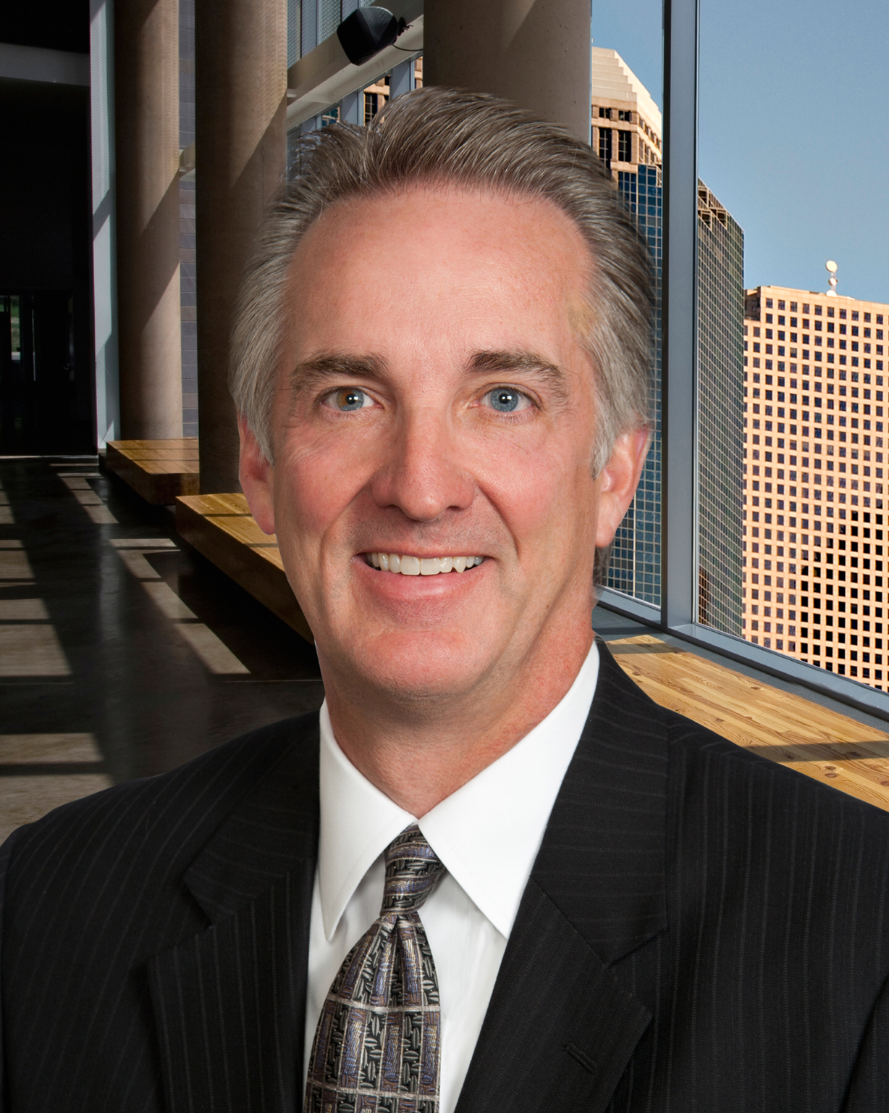

Bill Kinglsey has over 30 years of experience providing tax planning and strategic business consulting services to both public and privately held companies. He is a leader of the firm’s International Tax Committee and serves as a liaison to UHY International.

PROFESSIONAL EXPERIENCE:

•Extensive knowledge of international taxes and all areas of federal taxation including C corporation, S corporation, partnership and estate and gift

•Assists companies with mergers and acquisitions, international restructuring

•Proactive approach to developing planning techniques to minimize taxes for entrepreneurial and family owned businesses

BACKGROUND:

•Licensed CPA in the state of Michigan

•Before joining the firm, Bill was a lead client service partner with two large international accounting firms, where he developed several key initiatives for the firms including a China tax desk and service program for privately-held businesses

•B.S. in Business Administration and Accounting, Aquinas College

•MST in Taxation, Grand Valley State University

THOUGHT LEADERSHIP:

•Host and Co-Chairperson, UHY LLP International Roundtable Breakfast Series

•“10 Ways To Get the Most Out of Your Board”, UHY LLP 2015 Not-For-Profit Roundtable

•“State Taxes in the US”, UHY EMEA Regional Meeting, 2015

•“State Taxes in the US”, UK-US Breakfast Seminar, 2015

•“International Tax Update”, UHY Advisors Annual Tax Forum, 2010-2014

•“Cross-Border Mergers and Acquisitions in the United States”, International M&A Forum in Shanghai, China, 2013

•“Doing Business Outside the US”, UHY LLP Construction Outlook 2013, October 2012

•Climbing the BRIC Wall, UHY LLP International Roundtable, 2012

•Various outbound and inbound investment topics including current environment and opportunities, tax considerations, and China five year plan; UHY LLP China Investment, an international roundtable breakfast series, October 2011

•“International Tax Update and Transfer Pricing”, UHY Advisors Annual Tax Forum, 2010

•“Tax Planning for your China Operations”, Global Auto Industry Conference

•“New Sec. 263 Regulations”, Tax Executives Institute

PARTNER, UHY LLP

MANAGING DIRECTOR,

UHY ADVISORS MI, INC. - Detroit

INDUSTRY EXPERTISE:

•Manufacturing and Distribution

•Construction

•Staffing

•Technology

•Private Equity

ACTIVE & PRIOR PROFESSIONAL MEMBERSHIPS:

•Member – Detroit Economic Club

•Member – Detroit Chinese Business Association

•Member – Michigan Association of Certified Public Accountants

•Member – American Institute of Certified Public Accountants

ACTIVE & PRIOR CIVIC MEMBERSHIPS:

•Board Member – Downtown Detroit Partnership

•Trustee – Detroit Symphony Orchestra

•Former Board of Trustees – Nonprofit Enterprise at Work of Ann Arbor and Detroit

•Member – Detroit Athletic Club

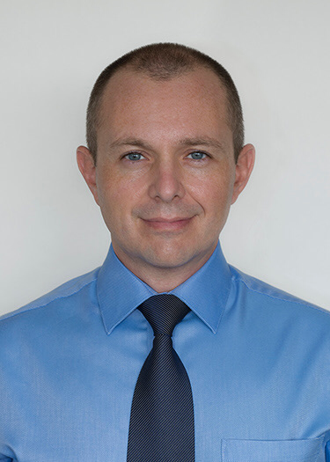Dr. Justin Hickman Prior to pursuing a career in medicine, Justin Hickman pursued a background in international economics and international affairs at the American University of Paris. He went on to work for Merril Lynch as a consultant for a brief period and then returned to complete a Masters in Sustainable Development at the School for International Training in Brattleboro, VT. He went on to manage the Rangaloka Health Centre, a rural medical clinic in Bangalore, India and eventually returned to the U.S. where he pursued his medial education at Virginia Commonwealth University in Richmond, VA. There he volunteered for several years with the Humanitarian Outreach Medical Brigada Relief Effort, a non-profit providing primary health care to underserved communities in Santo Domingo, Dominican Republic. Here he oversaw the implementation of the fEMR system in their medical missions. He continues to work in international medical missions where he manages pre-operative medical teams with the Volunteer Health Program, a yearly eye surgery mission, serving rural communities outside Santiago, Dominican Republic. Currently, he is pursuing his medical residency in Anesthesiology at the University of Virginia Medical Center in Charlottesville, VA.

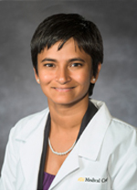

Dr. Sudha Jayaraman is a Trauma Surgeon and Surgical Intensivist from Virginia Commonwealth University. She has worked on trauma systems evaluation and capacity building in the LMIC setting since 2007 – including Uganda, Rwanda and Ecuador.

Dr. Jayaraman completed her General Surgery residency at University of California San Francisco (UCSF), during which she obtained a Masters’ Degree in Public Health in Developing Countries at the London School of Hygiene and Tropical Medicine (LSHTM). She did her Trauma and Critical Care fellowship at Brigham and Women’s Hospital/Harvard Medical School where she was awarded the Harvard Medical School Health Disparities Fellowship to work on injury epidemiology in Kigali, Rwanda.

Dr. Jayaraman has been an External Examiner at Department of Surgery, University Teaching Hospital, Kigali, Rwanda and visiting professor at the University of Cuenca and University of Azuay, Cuenca, Ecuador. She was appointed by Virginia’s Governor to the Advisory Board for Virginia State EMS in 2014 to advise the state of 6 million people on ensuring access to emergency services. She has been an author of numerous papers by Global Burden of Disease collaboration and the Cochrane Systematic Reviews Injury Group.

She is a Founding member and Advisor to the Global Partners in Anesthesia and Surgery 501c3 Organization based at UCSF.

She will advise on application of fEMR to clinical settings in LMICs and contribute to overall strategic planning.

